***COLOUR YOUR VEGGIES***

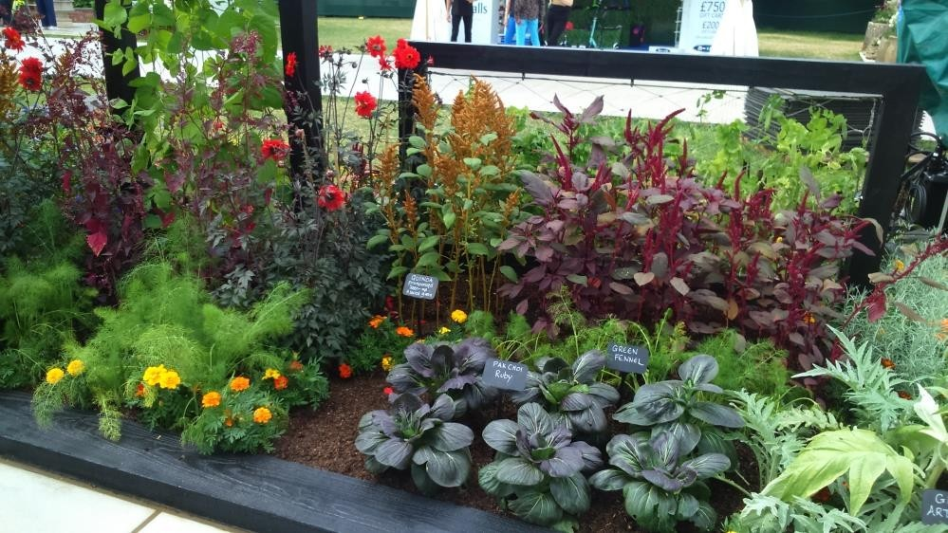

I’ve always been fascinated by colour in edible planting. This kitchen garden uses both colourful vegetables like the blue cabbages, chocolate millet, rainbow chard, purple kale, kohl rabi and pak choi interplanted with vibrant flowers – edible calendula flowers and dahlias (whose roots are the edible part – although not all varieties are said to taste good). In particular I loved the combination of dark Redbor kale with Dahlia ‘Bishop of Leicester’ with its deep purple foliage and soft pink blooms – no flowerbed could be more beautiful to my eyes.